**Level 1**

[**Test-cases**](https://docs.google.com/spreadsheets/d/14dNPVs1_T3S_76oD6IVQ5WPQHlWVwM0B6roe1EvYuaA/edit?usp=sharing)

* LIST USERS

Bug 1: difference in code - closing elements”

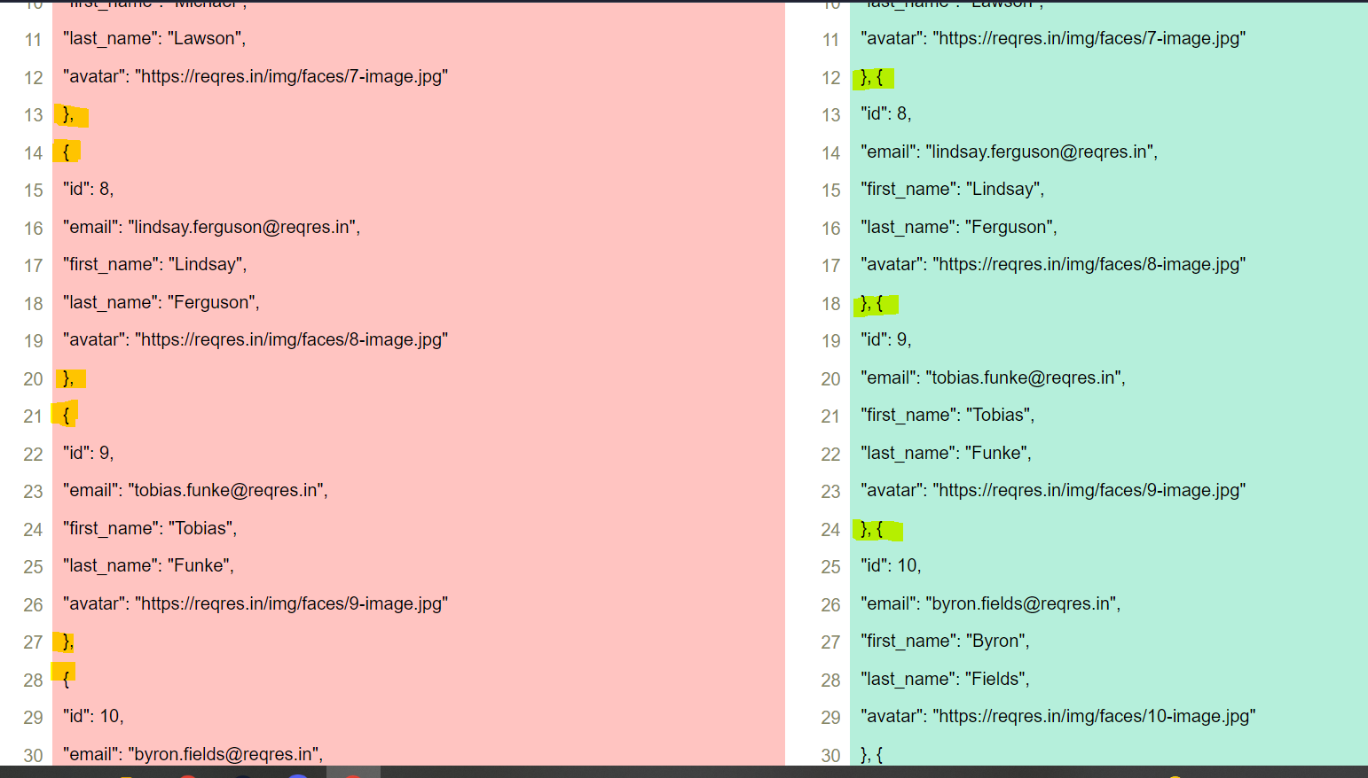

Bug 2: number of pages mentioned is not relevant during request:

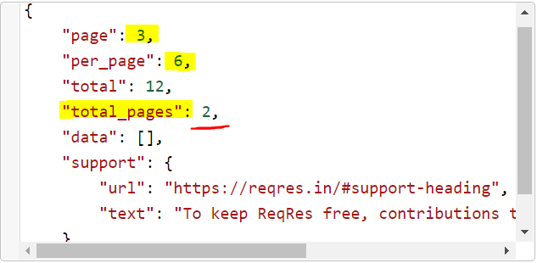

* SINGLE USER

Note: all 12 users are shown correctly. 404 (Not found) if you mention id 0 or 13 which is correct.

If put “null” instead of number ID - show only 1st page of list with 6 users

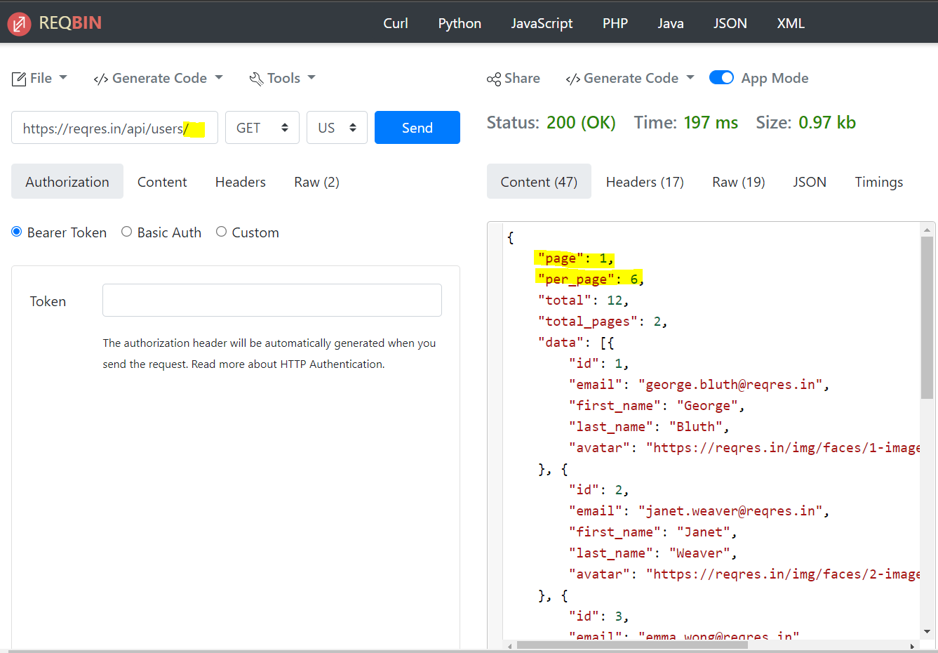

* CREATE

Note: ID is different from response example

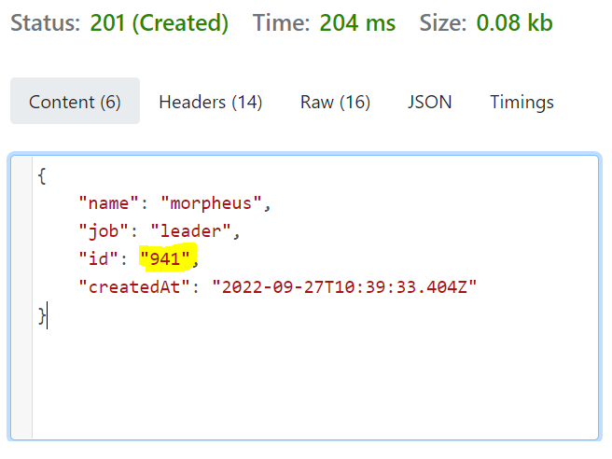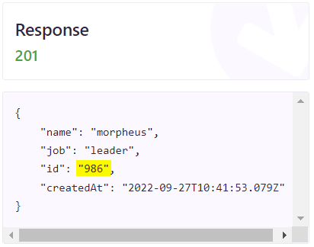

Bug: New created user id “941” shows 404 status code in Get “Single User”:

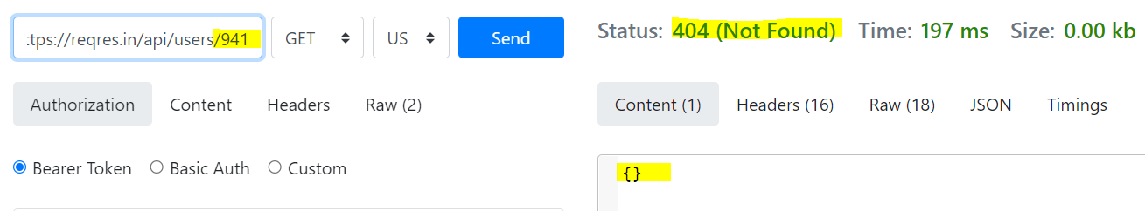

* UPDATE (PUT)

Bug: Status code 200 for update user 2 with not valid parameters:

“name” vs “first_name” - different title for name identification

“job” vs “null” - title “job” is missing in user description

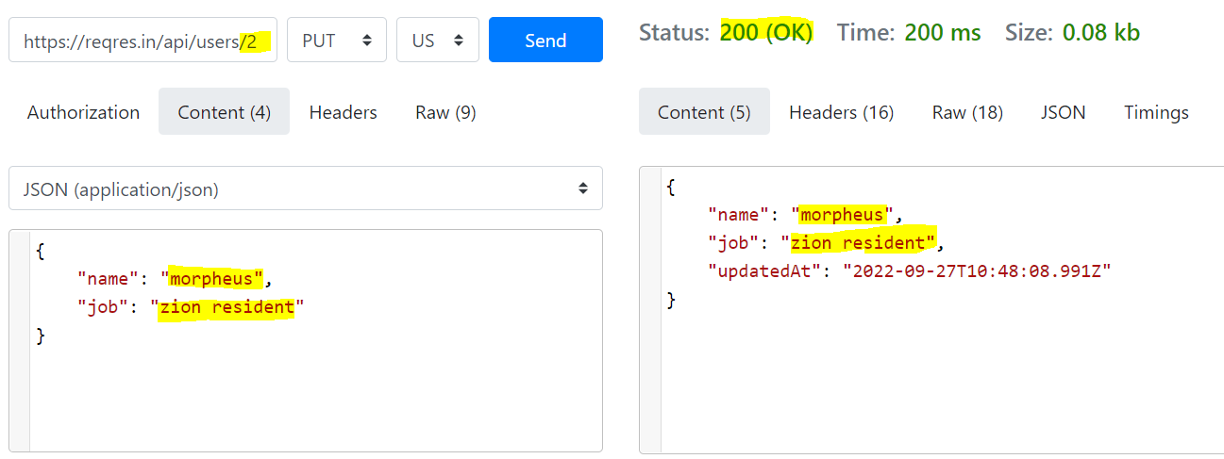

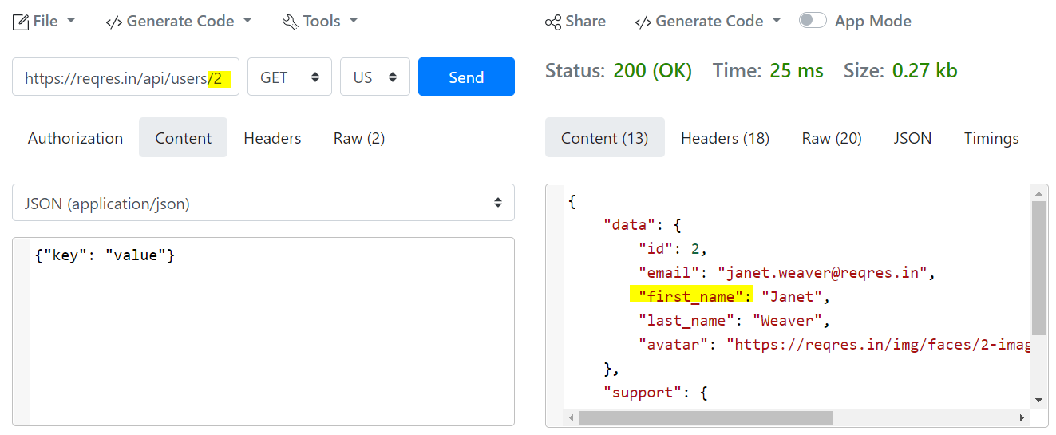

* UPDATE (PATCH)

Bug: the same as for PUT (info above).

Status 200 also for not existing users id (examples: 0, 13)

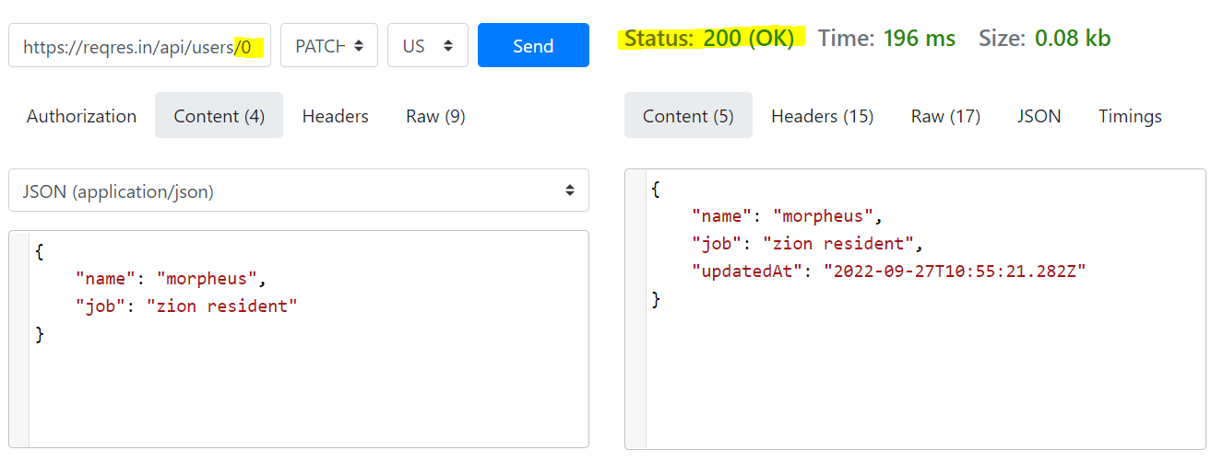

* DELETE

Bug: response status code 204 for all cases (for existing and not existing users). User id is not deleted.

* REGISTER - SUCCESSFUL

Bug: Status code 200 for already available user ID during registration

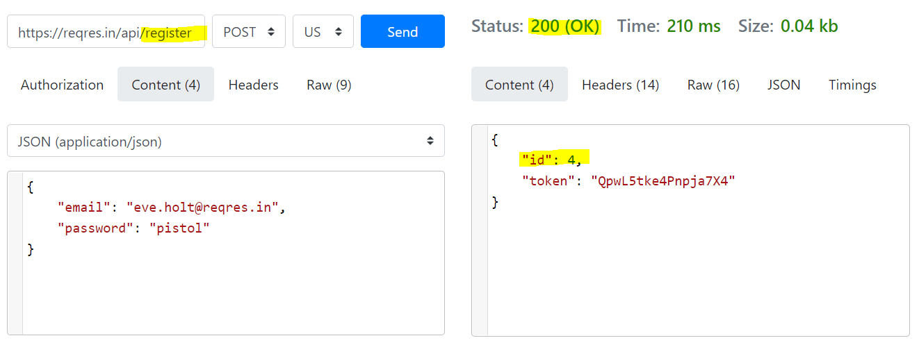

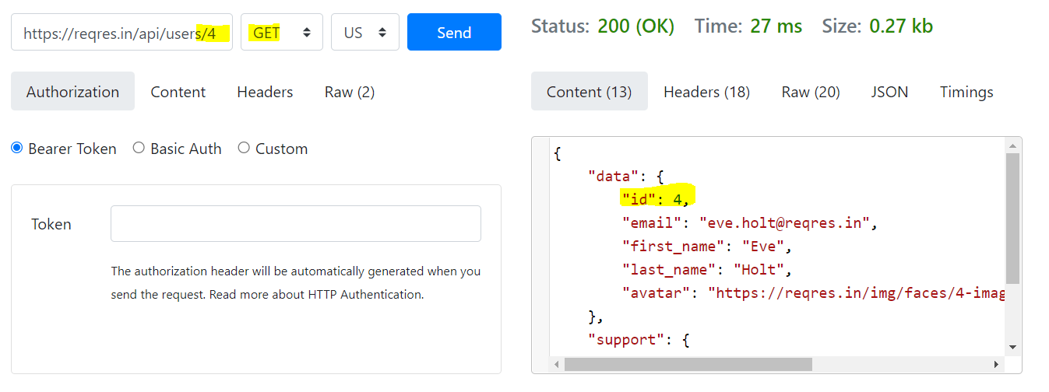

* LOGIN - SUCCESSFUL

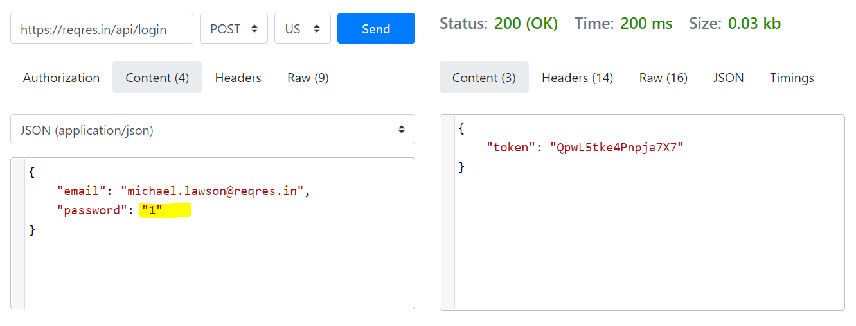

Bug: Password could consist of 1 symbol - token is released.

**Level 2,3**

